Using the HuddleCamHD SimplTrack2 Remote
***PLEASE DO NOT CHANGE CAMERA PRESET 1 OR 2, DOING SO WILL CAUSE THE AUTO TRACKING FEATURE TO STOP WORKING CORRECTLY***
***Auto tracking is turned on by default. Auto tracking can be turned off if it is not wanted by pressing the following button sequence: [F1] > [6] > [ENTER]
***If auto tracking is turned off, please re-enable it before the next class period by pressing the following button sequence: [F1] > [5] > [ENTER]
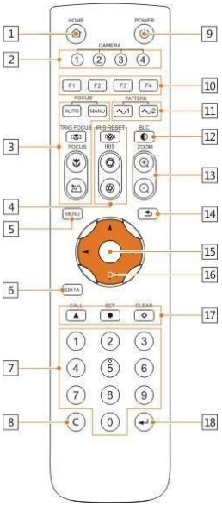
- HOME Button - Press the HOME Button to send the camera to the initial position where pan and tilt is 0.
- Camera Selection Button - Use to switch between IR channels for multiple camera control. For example, 4 is address 4.
- Focus - Use “AUTO” or “MANU” to select auto or manual focus. Trig Focus enables auto focus whenever the camera is zoomed. Near/Far allows for focus adjustment while in manual focus.
- Iris - Press Iris Reset to set iris back to default value or use Open/Close to open and close the Iris.
- Menu - Use to open/close the OSD Menu.
- Data Button - Use the Data Button to enable/disable display of pan/tilt angle, zoom time, and other prompt messages.
- Number Keys - Used for inputting numbers such as preset number.
8. Cancel Button - Cancel number input.
9. Power Button - User to power on/off the camera.
10. Shortcut Buttons (F1, F2, F3, F4) - Use these buttons for shortcut commands.
11. Pattern Buttons - Use to activate Pattern Scan 1 and Pattern Scan 2.
12. BLC Button - Use to enable/disable Backlight Compensation.
13. Zoom buttons - Use to zoom in or zoom out.
14. Back Button - Use the Back Button to go back to the previous menu.
15. OK Button - adjust pan/tilt control speed.
16. Direction/Menu - pan & tilt camera.
17. Preset Settings - Use the Number Keys to input a preset number, then press call, store, clear to perform the corresponding command.
18. Enter - After inputting numbers, press this button to confirm.

