**HuddleCam Remote**

POWER Button: This button is used to turn the camera on or off. If your application is not seeing the camera, look to see if the camera is on (camera will have a blue LED if on). If there is no blue LED, press the POWER button to turn the camera on.

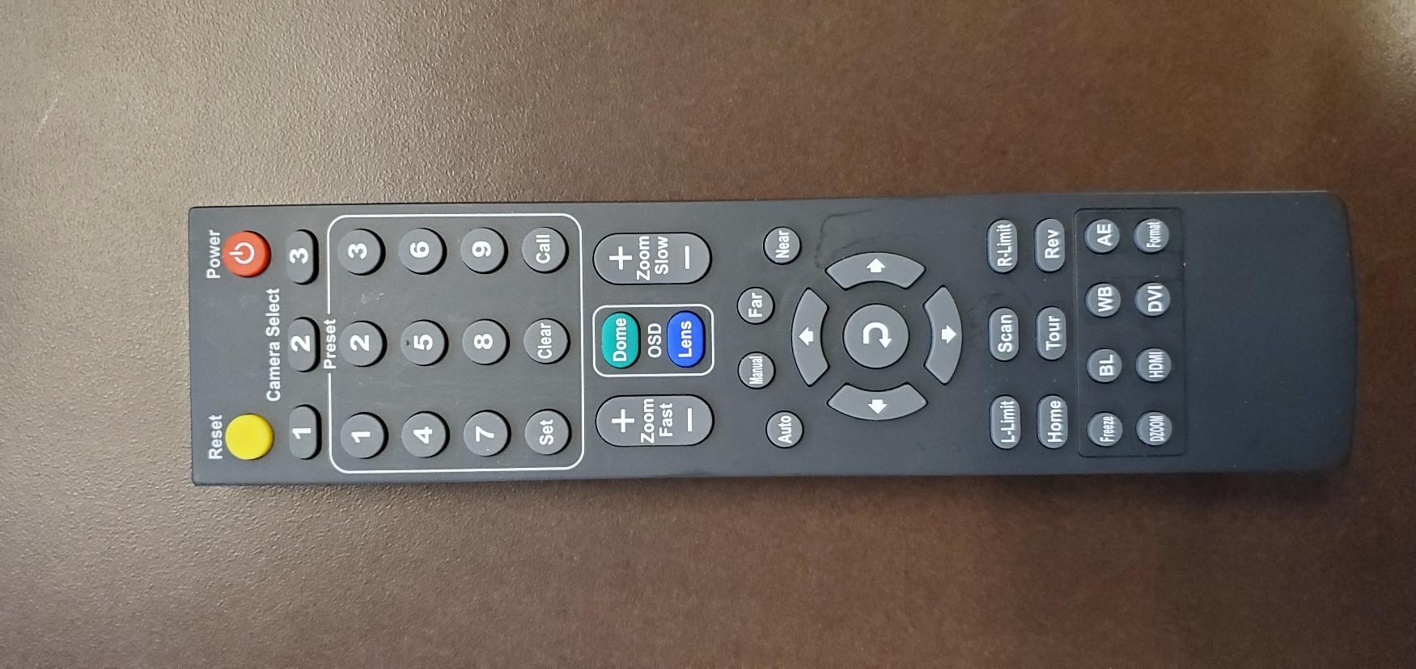

CAMERA SELECT Buttons: These buttons can be used to select individual cameras if there are more than one in the room. If camera is not responding to remote control commands, make sure camera 1 is selected.

PRESET Buttons: These buttons can be used to set and recall a camera position. To set a camera position, move the camera to the desired location, then press the preset number and SET button. To recall a preset, press the number and CALL button.

ZOOM Buttons: These buttons can be used to zoom the camera in or out.

ARROW Buttons: These buttons can be used to pan or tilt the camera.

REV Button: This button can be used to flip the camera image upside down or right-side up. When camera is mounted on ceiling, the image needs to be reversed.